|  |
| --- |
|  |

|  |  |
| --- | --- |
|  | **ASSIGNMENT TOP SHEET**  **Higher Diploma in Information Technology** |

|  |  |  |  |
| --- | --- | --- | --- |
| Student Registration Number | Student Name | | |
| SA23080744 | A.A.S.C.Amarasinghe | | |
| Lab Group | PC number | | |
|  | NA | | |
|  |  | | |
| Module Title : WAD | | | Module Code: IT207 |
| Lecturer in charge : | | | |
| Assignment Title : Project Proposal | | | |
| Due Date: | | Date Submitted:2023/09/20 | |
| Please Tick here if you have used a proof-reader for this assessment : | | | |
| Turnitin Paper ID* | | | |

*Not required if not submitting via Turnitin

SLIIT Academy Logo Final Colour

|  |  |
| --- | --- |
| **Declaration** | |
| I declare that work presented in the assignment submitted to the Sri Lanka Institute of Information Technology is a record of an original work done by myself*.* This assessment is submitted in the partial fulfilment of the requirement for the award of the degree of Bachelor of Science in Information Technology. The results embodied in this report have not been submitted to any other University or Institution for the award of any degree or diploma. Information derived from the published or unpublished work of others has been acknowledged in the text and a list of references is given. | |
| *Name(s) and Signature(s) :*  A.A.S.C.Amarasinghe | *Date:*  *2023/09/20* |

**Extension Deadline**

Lecturer in charge agrees that the assignment may be submitted ……………. days after the deadline and should be marked without penalty.

Lecturer in charge confirmation: ………………………………………………………………………………..

|  |
| --- |
| **Introduction and Description of the Project:**  Title: Casual Crest - Your one and only shopping destination. |

Introduction:

At Casual Crest, we believe that style should be accessible and affordable. Our online shopping store is designed to cater to all your fashion needs. We offer a wide range of trendy and timeless clothing that suits every occasion, mood, and any season. Our curated collection showcases the latest fashion trends, classic wardrobe staples, and unique pieces that help you express your personal style with confidence.

But Casual Crest is not just about clothing, it’s about the entire experience you get when you are shopping. Our website will give the users a very user-friendly website, seamless navigation, and a secure and hassle-free checking out process.

Join us on this fashion-forward journey and discover the joy of online shopping like never before. Your fashion adventure starts here, so explore our collections and elevate your style effortlessly.

* 1. **Problem Specification**

The current situation involves the absence of a dedicated shopping sales website for the business. The company relies on traditional marketing methods. we do have not proper websites for clothes buying. However, they recognize the need to establish an online presence to tap into the growing e-commerce market for shopping.

* 1. **Solution Outline**

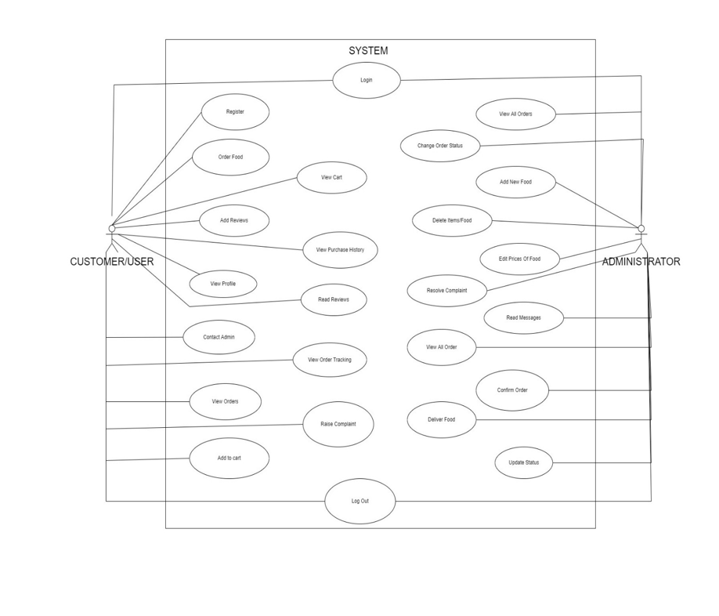

* 1. **Key Benefits**

Expanded Market:

1. The website breaks geographical boundaries, allowing the business to reach a global audience. It opens markets beyond the physical store's local reach.

Increased Sales Opportunities:

1. By tapping into the online market, the business can seize sales opportunities 24/7, including during peak shopping seasons and holidays.

Authenticity:

1. Authentication and certification of watches build trust with customers, especially for luxury and vintage pieces.

Product Information:

1. Detailed product listings with images, descriptions, and customer reviews help customers make informed purchase decisions.

Customer Support:

1. Integration of customer support channels ensures that customers receive timely assistance, enhancing their overall satisfaction.

Shopping:

1. Customers can shop at their convenience, browse a wide range of products, and have them delivered to their doorstep.

Global Shipping:

1. The availability of global shipping makes it easier for international customers to access high-quality watches.

**2. Details of System Functions**

**Register**

Customers can register to the system.

**Login**

Customers can log in to the System to make orders.

**View Menu - Customer**

Customers can view the Available Menu.

**Order clothes - Customer**

Customers can order clothes from the menu.

**Add To Cart – Customer**

Customers can add items to the cart.

**View Cart – Customer**

Customers can view the items added to the cart.

**Contact Admin**

Customers can send messages to the Admin.

**Add Reviews**

Customers can add reviews about the service, and clothes.

**Read Reviews**

Customers can read the reviews which are added by other customers.

**Raise Complaints**

Customers can raise complaints about clothes.

**Update Delivery Status – Customer**

After Receiving the order, the Customer make the order complete by making the Order Status

“Delivered”.

**View Profile - Customer**

Customers can view the Profile details.

**View New Orders – Admin**

Admin can view all the new orders.

**Update Delivery Status - Admin**

Admin will change the status to “On the way” when the Order is on the way to the Customer.

**View On the Way Orders**

Admin can view all the on-the-way orders.

**View Completed Orders**

Admin can view all the orders that are delivered to the Customers.

**View Contact Messages**

Admin can view all the Messages that are sent by Customers.

**Add New items.**

Admin can add new items to the menu.

**Delete items.**

Admin can delete the items from the menu.

**View Items List.**

Admin can view all the available foods.